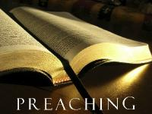
Sermon-Based Discussion Guide
Based on I Am Second Group Questions

Westwood Baptist Church, Alabaster, Alabama
WestwoodGroups.com

Questions for Use with Any Scripture

Review

Review last week's commitments to action. See question #6 and ask for feedback from group members.

Discussion Questions

Read today's focus passage.

1. What do you like about the passage?

2. What do you dislike or find confusing?

3. What do we learn about God from this passage?

4. What do we learn about man, or about ourselves?

5. How is God speaking to you through this passage?

6. What specific thing will you do this week to be obedient to what God is speaking to you?

