Sermon-Based Discussion Guide

Westwood Baptist Church, Alabaster, Alabama
Jay Gordon, Pastor of Small Groups
Trey Murphy, Home Groups Director
WestwoodGroups.com

Honoring Dad
June 19, 2011
Les Hughes, Senior Pastor

SCRIPTURE

Ephesians 6: 1-3
Children, obey your parents in the Lord, for this is right. ² “Honor your father and mother”—which is the first commandment with a promise— ³ “so that it may go well with you and that you may enjoy long life on the earth.”

ENGAGE

This day and age may be the toughest time to be a dad/parent. What challenges do you face as a parent and especially as a dad?

DISCUSS

What issues do you have with your children when it comes to obedience? What about your walk with Christ? Do you follow obedience in the Lord or do you act more like your children?

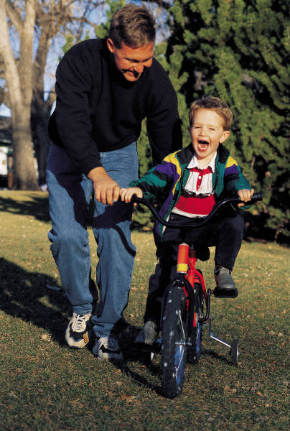
Biblical obedience is doing what we are asked to do when God asks and with the right attitude. Do you always do what you are asked to do with a good attitude? If you knew everything you were doing glorifies God how would your attitude be then?

What conflicts do you see in the family when it comes to your kids (brother/sister issues)? What kind of example are you setting when it comes to conflict resolution?

As adults what issues do you have with your parents? Do you have a loving and respectful relationship with them? What steps can you take to mend any issues you may have with them?

YOUR NEXT STEP

Our children tend to watch and copy what we do. As Christian parents, we should be setting examples for our children on how to be honorable. Are you the example you should be? What would it take to get there?

CHILDREN’S TIME

The Bible gives us plenty of scriptures on honoring your dad/parents. Three specific things that God expects of us are:
- Practice immediate obedience
- Avoid conflict with other family members (brothers and sisters)
- Trust in Jesus as your Lord and Savior

God and your parents want your immediate obedience. Do you always listen, obey and respond with a loving and willing heart? Are you honoring your parents and your heavenly Father by doing what is asked of you?

What issues do you have with your family members? Are they always the ones causing the problems or do you have some part in the problems? Do you treat them the same as your friends? What steps can you take to make things better?

As a first step in making things better you can put your trust in Jesus as your Lord and Savior. Have you already done this? What questions do you have about your salvation?

Teenagers: (use above questions as needed and use some of these too)

What struggles do you face as a teenager when it comes to remaining pure? What do you see friends doing that you know is wrong? Do you ever compelled to confront them to let them know that what they are doing is wrong?

Respect for other family members:
Do you have any issues with your family members? Share what those issues are and what you can do to change your attitude about them.

Being responsible and making good decision can lead to more freedoms. What things around the house or in your life can you do to show these?

OTHER PASSAGES SITED

Proverbs 1:8-9
Psalm 133:1
Matthew 19:14
Psalm 119:9-11
1 Corinthians 13:4-5

