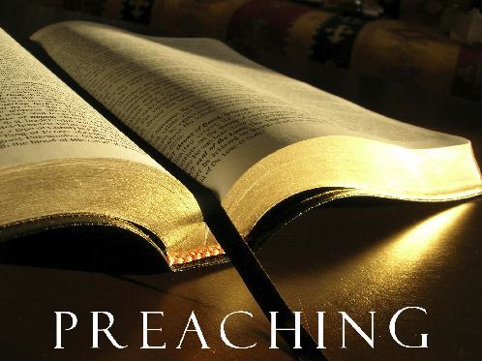
Sermon-Based Discussion Guide for Home Groups
Westwood Baptist Church, Alabaster, Alabama
Jay Gordon, Pastor of Small Groups
Trey Murphy, Home Groups Director
WestwoodGroups.com

“The World’s Most Perfect Food”
November 28, 2010
David Johnson, Global Missions Pastor

Scripture

John 6:26-27
²⁶ Jesus answered, “Very truly I tell you, you are looking for me, not because you saw the signs I performed but because you ate the loaves and had your fill. ²⁷ Do not work for food that spoils, but for food that endures to eternal life, which the Son of Man will give you. For on him God the Father has placed his seal of approval.”
John 6:29
²⁹ Jesus answered, “The work of God is this: to believe in the one he has sent.”

John 6:32-33
³² Jesus said to them, “Very truly I tell you, it is not Moses who has given you the bread from heaven, but it is my Father who gives you the true bread from heaven. ³³ For the bread of God is the bread that comes down from heaven and gives life to the world.”
John 6:35-40
³⁵ Then Jesus declared, “I am the bread of life. Whoever comes to me will never go hungry, and whoever believes in me will never be thirsty. ³⁶ But as I told you, you have seen me and still you do not believe. ³⁷ All those the Father gives me will come to me, and whoever comes to me I will never drive away. ³⁸ For I have come down from heaven not to do my will but to do the will of him who sent me. ³⁹ And this is the will of him who sent me, that I shall lose none of all those he has given me, but raise them up at the last day. ⁴⁰ For my Father’s will is that everyone who looks to the Son and believes in him shall have eternal life, and I will raise them up at the last day.”

Engage

What are your thoughts on this question: “What is the most perfect food?”

Discuss

1. John 6:49 says the people of Israel ate manna and ultimately died. Therefore, there is no physical food that will bring us eternal life. Today we’ll see that spiritually speaking, Jesus is the bread that gives us eternal life.
Why do you think Jesus used the analogy of hunger and thirst?

2. Read John 6:46-47. Why do you think so many people are totally focused on the physical and overlook the spiritual factors in life?

3. What’s wrong with the question “What must we do to be saved?”

Read John 6:49.

What is required for a person to be saved? How can we know if we are saved?

4. Read John 6:35-40. What truths do we take from this verse?

5. We are saved by grace alone, through faith alone, in Christ alone. What does grace mean?

6. Read Romans 3:28. What does this passage clarify for us? Why do so many people believe that we can be saved by doing good things?

7. For believers, the takeaway is our responsibility to share the simple message of Christ. What do you think keeps so many believers from sharing our faith in Christ with others?

8. Share with the group how you came to know Christ.

Your Next Step

Believe in Christ if you have not done so. If you have, share Christ with one person this week.

Other Passages Cited

John 6:49
Eph. 2:8-9
Rom. 3:28
John 6:29
Rom. 10:9
Acts 16

