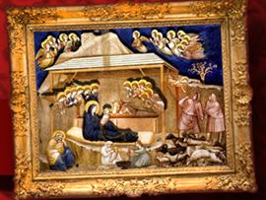
Sermon-Based Discussion Guide for Home Groups
Westwood Baptist Church, Alabaster, Alabama
Jay Gordon, Pastor of Small Groups
Trey Murphy, Home Groups Director
WestwoodGroups.com

Silent Night
December 26, 2010
Series: Christmas Songs
Les Hughes, Senior Pastor

Note

There is no sermon-based lesson for small groups for today.
Groups are not meeting due to the Christmas holiday.

Luke 2:18-19
¹⁸ and all who heard it were amazed at what the shepherds said to them. ¹⁹ But Mary treasured up all these things and pondered them in her heart.

